COMPUTER MOUSE
TRINKERCAD STIMULATION &ARDUINO PROGRAMMING

PROJECT OVERVIEW :
- This project demonstrates a Computer Mouse Which is a Pointing Device and tested in Tinkercad ,progrmmed on Arduino.
- The system uses Pointing & Selecting –,Clicking ,Dragging & Dropping ,Scrolling ,Drawing & Designing ,Gaming,Editing Text ,Navigation

1.Objectives
- Design and simulate the circuit in Tinkercad using identified components.
- Program the Arduinoto control the monitoring computer on the mouse.

2. Introduction
A computer mouse is a small hand-held input device used to interact with a computer. It allows users to control the movement of the pointer on the screen and perform actions such as clicking, selecting, dragging, and scrolling. The mouse makes it easy to navigate software, open files, and use applications efficiently. Because of its simplicity and accuracy, the computer mouse has become an essential tool in everyday computer use.
3. Block Diagram
Overall system flow is shown below :

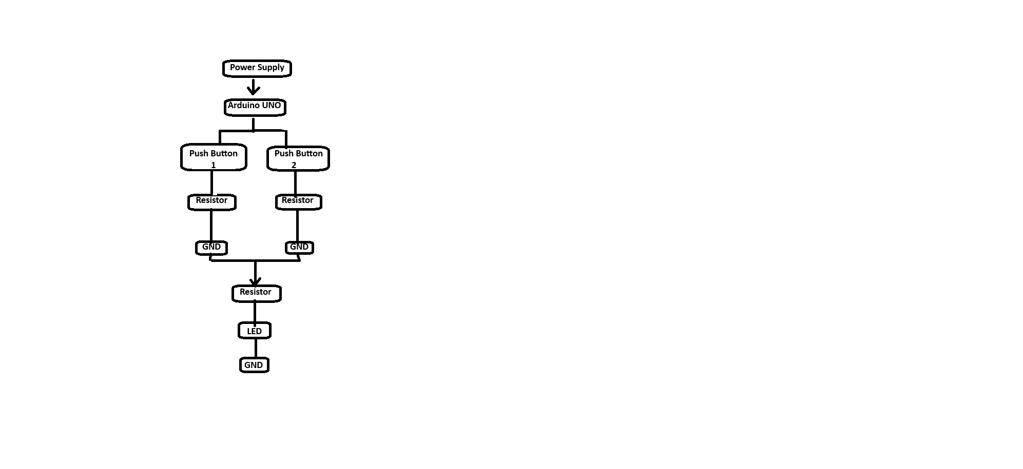
Components
Name | Quantity | Component | Purpose
U1 | 1 | Arduino Uno R3 | Acts as the main controller.
D1 | 1 | Red LED
  Indicates status or action
R1 | 1 | 100 Ω Resistor | Limits the current flowing through the LED to prevent damage.
S3, S4 | 2 | Pushbutton | Acts as mouse buttons
R2, R3 | 2 | 1 kΩ Resistor
  Used as a pull-down or pull-up resistor to ensure stable button input and avoid false triggering.

Wiring & Pin Diaram
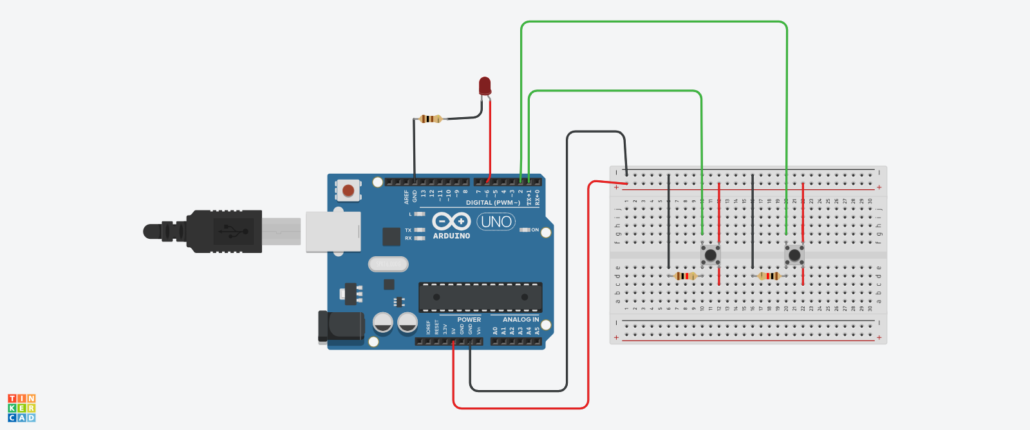

Arduino Pin | Signal /module
5V | Breadboard + rail
GND | Breadboard – rail
D2 | Push Button 1
D3 | Push Button 2
D7 | Red LED (via 100 Ω resistor)
GND | LED cathode

Building circuits in tinkercad

- Create a new tinkercad project
- Click and drag parts from the library. Use the rotate button to change their orientation.
- Click on a component's terminal (e.g., battery positive/negative) and drag to another component's terminal to create a wire. Double-click to change wire direction, keeping corners rectangular for neatness.
- Add a breadboard to easily connect multiple components without crossing wires, which is great for prototyping.
- Add a breadboard to easily connect multiple components without crossing wires, which is great for prototyping.

Arduino Code
int button1,button2;
void setup()
{
pinMode(1,INPUT);
pinMode(2,INPUT);
pinMode(6,OUTPUT);
}

void loop()
{
button1=digitalRead(1);
button2=digitalRead(2);
if(button1==HIGH)digitalWrite(6,HIGH);
if(button2==HIGH)digitalWrite(6,LOW);
}
Code Explanation

This Arduino program is used to control an output device such as an LED using two push buttons. Two integer variables, button1 and button2, are declared to store the input states of the buttons. In the setup() function, pin 1 and pin 2 are configured as input pins to which the buttons are connected, and pin 6 is configured as an output pin connected to the LED or any other device. The loop() function runs continuously and reads the status of both buttons using digitalRead(). If the button connected to pin 1 is pressed (HIGH), pin 6 is set to HIGH, which turns the LED ON. If the button connected to pin 2 is pressed (HIGH), pin 6 is set to LOW, which turns the LED OFF. Thus, one button is used to turn the output ON and the other button is used to turn it OFF.

Testing &Debbuing in tinkercad
In Tinkercad, the circuit is tested by first creating the Arduino Uno setup with two push buttons and an LED as shown in the diagram. After completing the wiring, the given Arduino code is uploaded to the virtual Arduino by clicking the Start Simulation button. During testing, when the first push button is pressed, the LED connected to pin 6 should turn ON, and when the second push button is pressed, the LED should turn OFF. This confirms that the inputs and output are working correctly as expected.
For debugging, if the LED does not respond properly, the wiring connections are checked to ensure the buttons are connected to the correct digital pins and the LED has a current-limiting resistor. The input pin modes and output pin mode are verified in the code. Tinkercad’s simulation highlights signal changes, which helps identify loose or incorrect connections. By correcting wiring mistakes or pin number errors and restarting the simulation, the circuit can be debugged and tested successfully.
What if Testing & Behavior Analysis
In this circuit, what-if testing is used to understand how the system behaves under different conditions in Tinkercad simulation. What if Button 1 is pressed? The Arduino reads a HIGH signal on pin 1, so the LED connected to pin 6 turns ON. What if Button 2 is pressed? The Arduino reads a HIGH signal on pin 2, so the LED turns OFF. This confirms the intended ON/OFF control behavior.
What if both buttons are pressed at the same time? The program checks Button 1 first and turns the LED ON, then checks Button 2 and turns it OFF, so the LED finally remains OFF. What if no button is pressed? Both inputs remain LOW and the LED stays in its previous state. What if a button is held continuously? The LED remains in the corresponding ON or OFF state without flickering. This behaviour analysis helps verify that the circuit and code respond correctly to different input conditions and ensures reliable operation before using the circuit in real hardware.
Observations
https://www.tinkercad.com/things/0n3aIQ6qrqQ-terrific-hillar-blorr

